**Constructor Example**

1. Write a program with a class name, constructor(to initialize the instance value by receiving data from user), and method(to display the value).

class const:

def __init__(self):

print("Inside Constructer")

self.a=int(input())

self.b=input()

self.c=float(input())

def display(self):

print("a=",self.a,"b=",self.b,"c=",self.c)

pass

ob=const()

ob.display()

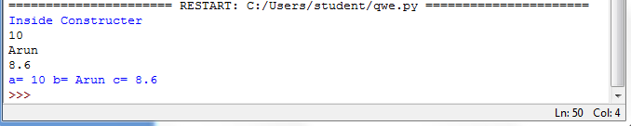

1. Write a program with a class name, constructor(to initialize the instance value by receiving data as parameters), and method(to display the value).

class const:

def __init__(self,a,b,c):

print("Inside Constructer")

self.a=a

self.b=b

self.c=c

def display(self):

print("a=",self.a,"b=",self.b,"c=",self.c)

pass

a=int(input())

b=input()

c=float(input())

ob=const(a,b,c)

ob.display()

